2021 07 12 Grace employment page update
https://www.gracepacific.com/employment
Change wording on the submission form from Application Form to Apply Here
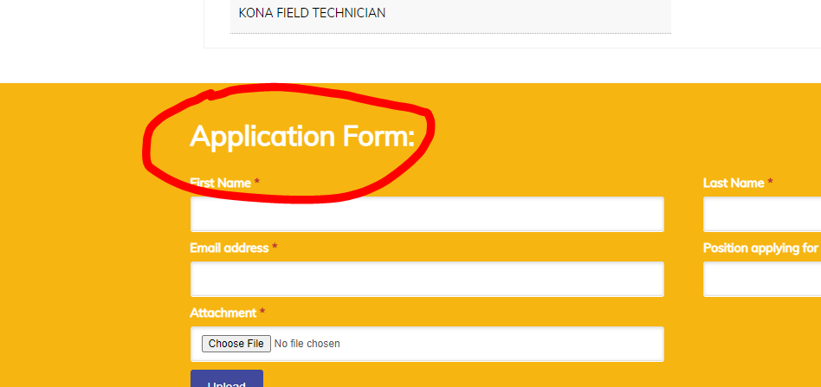

On this submission form we allow the applicant to submit the application. Can we also add one of the following, whatever is easiest? Either one is fine:
- Another button to allow them to add a resume. Label one Application and one Resume.
- Allow more than one attachment. If we could allow them to attach 3 different files that would be good.

